简单使用git管理代码

一、进行初始化

Git global setup
git config --global user.name "tai"
git config --global user.email "taichong@yunify.com"

Create a new repository
git clone git@git.internal.yunify.com:chong/test.git
cd test
touch README.md
git add README.md
git commit -m "add README"
git push -u origin master
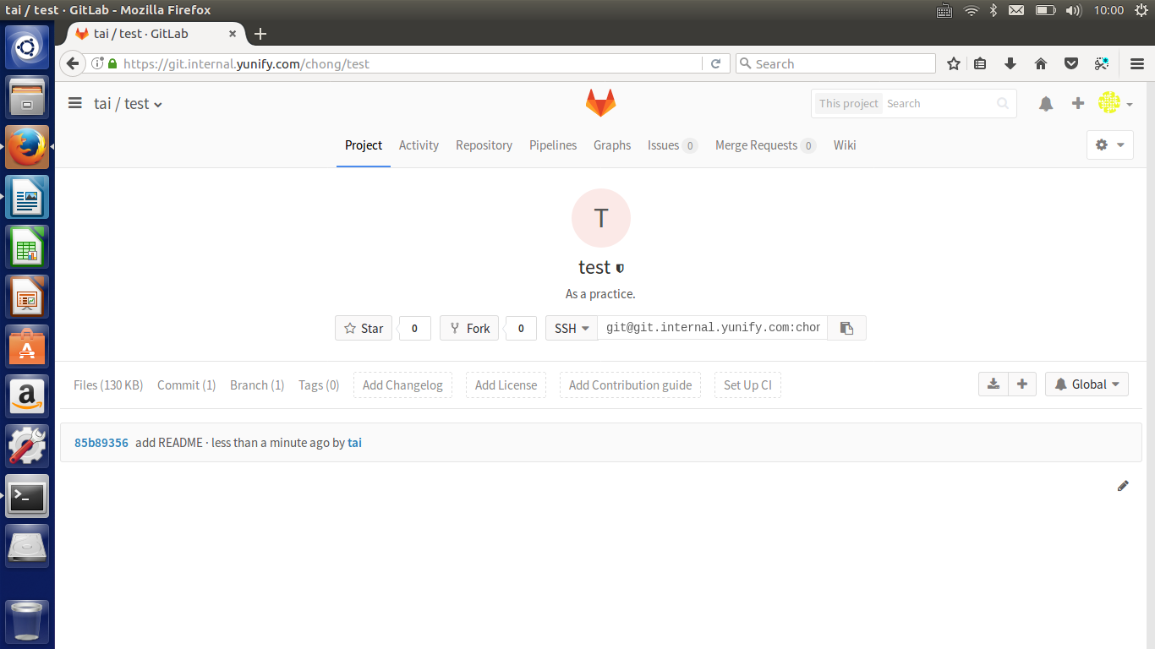
至此创建完成
————————————
二、编写简单代码并推到project
1、首先建立分支并切换到分支下
taichong@yunify-ThinkPad-T450:~/test/test$ git branch
* master
taichong@yunify-ThinkPad-T450:~/test/test$ git checkout -b test1
Switched to a new branch 'test1'
taichong@yunify-ThinkPad-T450:~/test/test$ git branch
master
* test1
2、下拉master的内容，进行编辑
taichong@yunify-ThinkPad-T450:~/test/test$ git pull origin master
From git.internal.yunify.com:chong/test
* branch master -> FETCH_HEAD
Already up-to-date.
3、如果希望添加除了master上之外的文件需要
git add file_name
git commit file_name——》这时会出现一个vim形式的文档里面是你要添加的文件的一些记录信息，需要进去编写一个标题，作为这次提交的标题
4、上推这次提交
git push --set-upstream origin file_name
Counting objects: 3, done.
Delta compression using up to 4 threads.
Compressing objects: 100% (3/3), done.
Writing objects: 100% (3/3), 340 bytes | 0 bytes/s, done.
Total 3 (delta 0), reused 0 (delta 0)
remote:
remote: Create merge request for test1:
remote: https://×××××××××××××××××/chong/test/merge_requests/new?merge_request%5Bsource_branch%5D=test1 ——》发送这个连接给当前project的master，让他进行审核
remote:
To git@git.internal.yunify.com:chong/test.git
* [new branch] test1 -> test1
Branch test1 set up to track remote branch test1 from origin.
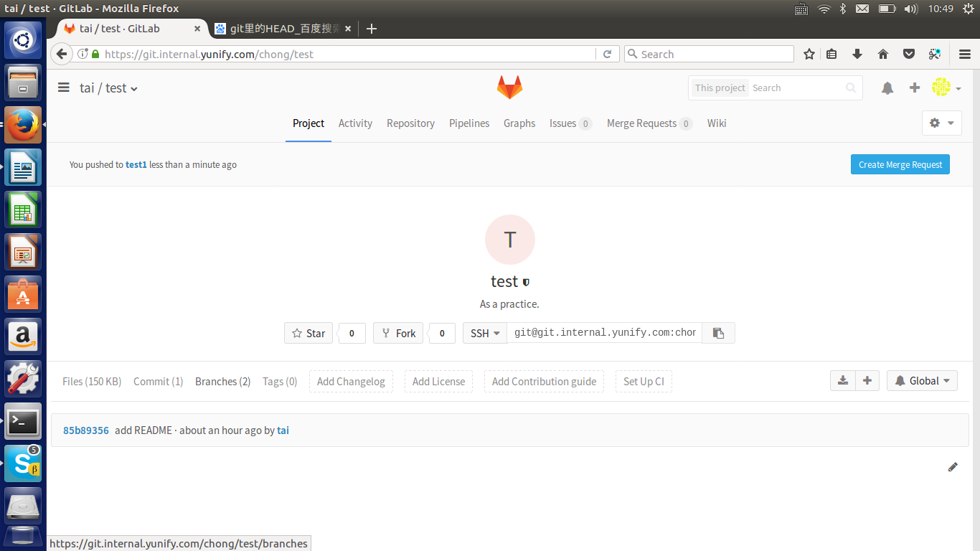
这时会发现branch变成了2.说明当前有两个分支。
至此，你的提交完成
————————————
三、当master merge commit之后，你会发现自己写的代码在master上出现了
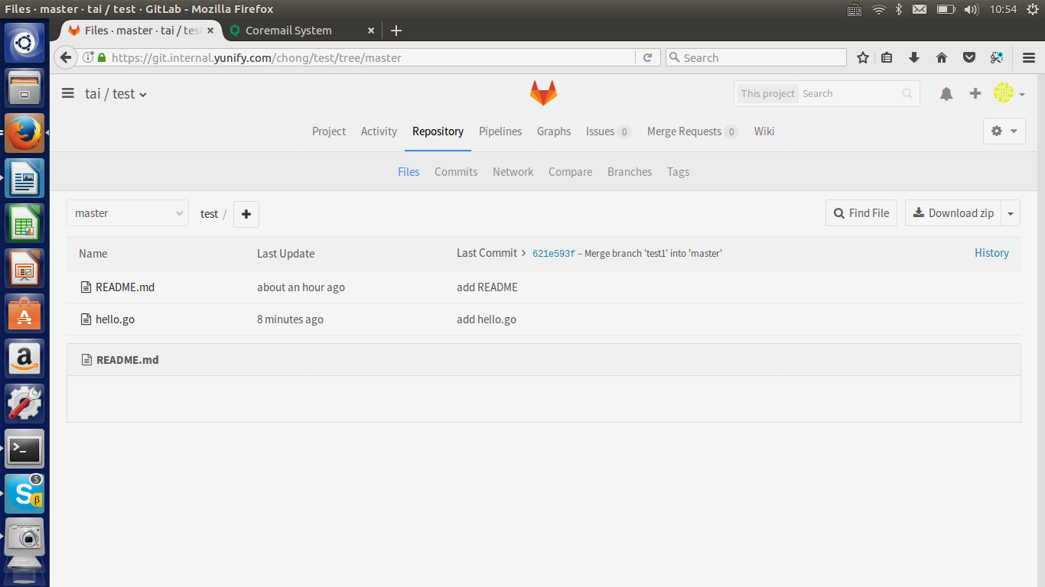
四、删除远程和本地分支
当你的任务提交并merge之后，在确认确实没有必要留着分支的时候，需要删除自己建立的分支。一是为了节省空间，二是为了代码和界面整洁度。对于开源来说，整齐的代码才更有竞争力。
1、查看一下当前所有的分支，包括远程和本地
git branch -a
master
* test1
remotes/origin/master
remotes/origin/test1
2、确定自己要删除的分支，进行删除
（1）删除远程分支
在Git v1.7.0 之后，可以使用这种语法删除远程分支：
git push origin –delete BranchName
删除tag这么用：
git push origin –delete tag TagName
否则，可以使用这种语法，推送一个空分支到远程分支，其实就相当于删除远程分支：
git push origin :BranchName
这是删除tag的方法，推送一个空tag到远程tag：
git tag -d TagNamerefs/tags/<tagname>
git push origin :refs/tags/TagName
演示：
删除远程：
taichong@yunify-ThinkPad-T450:~/test/test$ git branch -a
master
* test1
remotes/origin/master
remotes/origin/test1
taichong@yunify-ThinkPad-T450:~/test/test$ git push origin :test1
To git@git.internal.yunify.com:chong/test.git
- [deleted] test1
taichong@yunify-ThinkPad-T450:~/test/test$ git branch -a
master
* test1
remotes/origin/master
（2）删除本地分支
git branch -d BranchName
注意，无法删除当前分支，需要先做切换
taichong@yunify-ThinkPad-T450:~/test/test$ git branch -d test1
error: Cannot delete the branch 'test1' which you are currently on.
taichong@yunify-ThinkPad-T450:~/test/test$ git branch
help
master
* test1
taichong@yunify-ThinkPad-T450:~/test/test$ git checkout master ——》切换到master
Switched to branch 'master'
Your branch is up-to-date with 'origin/master'.
taichong@yunify-ThinkPad-T450:~/test/test$ git branch -d test1
Deleted branch test1 (was 85b8935).
taichong@yunify-ThinkPad-T450:~/test/test$ git branch -a
help
* master
remotes/origin/master
五、进阶篇
当你pull master之后，进行修改，直到你进行push操作之间，有其他人也在对master进行修改，而且，你们修改的很可能是同一个文件的时候，该怎么做呢？
If someone else made changes to the master branch while you were working on your branch, you could pull in those updates. ————来自github
假设你现在基于远程分支"origin"，创建一个叫"test2"的分支。
git checkout -b test2
创建两个提交
（1）第一个commit，注意，git commit --amend可以理解成基于上次commit继续追加
$ git add a.txt
taichong@yunify-ThinkPad-T450:~/test/test$ git commit
[test2 c73a536] The first commit
1 file changed, 0 insertions(+), 0 deletions(-)
create mode 100644 a.txt
taichong@yunify-ThinkPad-T450:~/test/test$ touch b.txt
taichong@yunify-ThinkPad-T450:~/test/test$ git add b.txt
taichong@yunify-ThinkPad-T450:~/test/test$ git commit --amend
[test2 40f3725] The first commit merge a b.txt
Date: Fri Nov 10 11:44:07 2017 +0800
2 files changed, 0 insertions(+), 0 deletions(-)
create mode 100644 a.txt
create mode 100644 b.txt
（2）第二次提交
taichong@yunify-ThinkPad-T450:~/test/test$ touch c.txt
taichong@yunify-ThinkPad-T450:~/test/test$ git add c.txt
taichong@yunify-ThinkPad-T450:~/test/test$ git commit c.txt
[test2 b51d80a] The second commit
1 file changed, 0 insertions(+), 0 deletions(-)
create mode 100644 c.txt

但是与此同时，有些人也在"origin"分支上做了一些修改并且做了提交了. 这就意味着"origin"和"mywork"这两个分支各自"前进"了，它们之间"分叉"了。
在这里，你可以用"pull"命令把"origin"分支上的修改拉下来并且和你的修改合并； 结果看起来就像一个新的"合并的提交"(merge commit):
taichong@yunify-ThinkPad-T450:~/test/test$ git pull origin master
From git.internal.yunify.com:chong/test
* branch master -> FETCH_HEAD
Merge made by the 'recursive' strategy.
d.txt | 0
1 file changed, 0 insertions(+), 0 deletions(-)
create mode 100644 d.txt
taichong@yunify-ThinkPad-T450:~/test/test$ ls
a.txt b.txt c.txt d.txt hello.go README.md
taichong@yunify-ThinkPad-T450:~/test/test$ git push --set-upstream origin test2
Counting objects: 6, done.
Delta compression using up to 4 threads.
Compressing objects: 100% (6/6), done.
Writing objects: 100% (6/6), 699 bytes | 0 bytes/s, done.
Total 6 (delta 2), reused 0 (delta 0)
remote:
remote: Create merge request for test2:
remote: https://××××××××××××/chong/test/merge_requests/new?merge_request%5Bsource_branch%5D=test2
remote:
To git@git.internal.yunify.com:chong/test.git
* [new branch] test2 -> test2
Branch test2 set up to track remote branch test2 from origin.
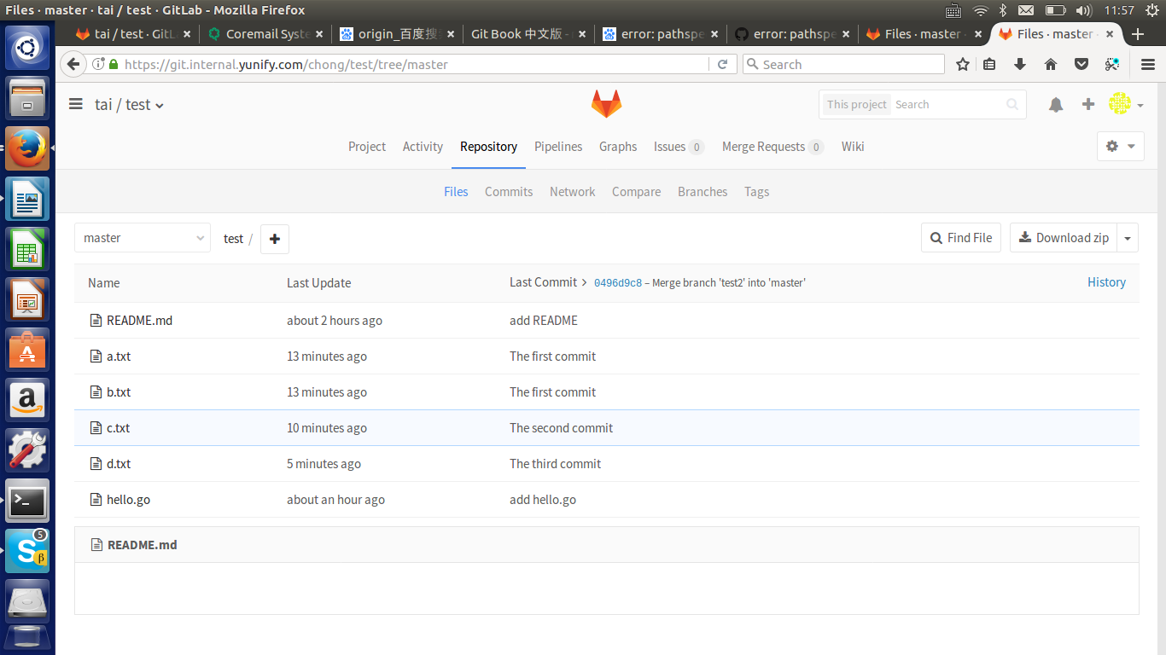
但是，这样操作，你会发现很多次的commit记录
commit 08578f476219b411f08feac42fa322a0e016a8a8
Merge: b51d80a e416a9f
Author: tai <taichong@yunify.com>
Date: Fri Nov 10 11:56:55 2017 +0800

Merge branch 'master' of git.internal.yunify.com:chong/test into test2

commit e416a9fe85c309486a254c76b1f6ba4152a77b4f
Merge: 621e593 b151b2e
Author: tai <taichong@yunify.com>
Date: Fri Nov 10 11:56:14 2017 +0800

Merge branch 'help' into 'master'

The third commit

See merge request !2

commit b151b2e12bdaed80724c8759b92d33ab0e1632f6
Author: tai <taichong@yunify.com>
Date: Fri Nov 10 11:53:15 2017 +0800

The third commit

commit b51d80a7a89efd88798d814d329f00096df05976
Author: tai <taichong@yunify.com>
Date: Fri Nov 10 11:47:59 2017 +0800

The second commit

commit 40f372526b2cf4b88b25deb65ad5cb67bde8a6e7
Author: tai <taichong@yunify.com>
Date: Fri Nov 10 11:44:07 2017 +0800

The first commit
merge a b.txt
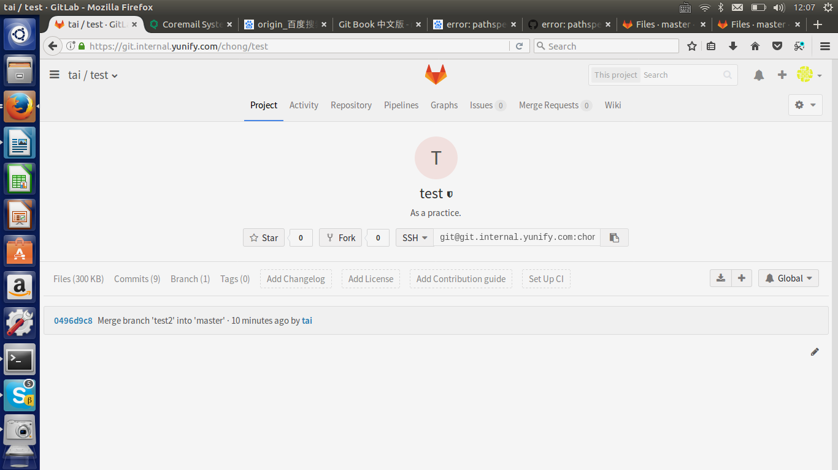
【注意】：
目前commit信息很多，所以，我这里先清楚commit到只有两个文件的时候。
git rm a.txt b.txt c.txt d.txt ————》git add a.txt b.txt c.txt d.txt
————》git push origin master ————》git push -f
如果commit记录增长很多，看起来会很乱。所以为了减少review的工作量和复杂度，建议采用下面的方法：
http://blog.csdn.net/chenansic/article/details/44122107
如果想简单了解git运行方式，可以访问：
https://guides.github.com/activities/hello-world/

